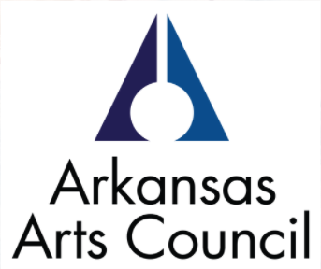
Goals and Objectives
1. Goals
Goals are broad statements that are usually general and issue-focused with realistic priorities. Goals are a long-term end to which programs and activities (methods) are developed.
2. Objectives
Objectives are specific measurable ends that are achievable within a time frame and mark progress towards achieving an associated goal(s). Objectives should be clear targets for specific action (activities) and mark measurable steps towards reaching a goal.
Example: Increase the number of Pulaski County community members age 75 and older that participate in visual art and science classes at the XYZ Museum during fiscal year 2011-2012 by 25%.
3. Activities
Specific activities (methods) are used to achieve the objectives.
Example: Expand the Fall class offerings by 15% by adding two additional classes in watercolor and introducing a nature class.
4. Evaluation Plan
Evaluation plans should center on the project goals and objectives. An evaluation should focus on methods and processes for gathering, analyzing, and reporting data to evaluate your programming with the purpose of improving, deciding to continue, or stopping.
Examples of evaluation tools:
- Worksheets
- Quizzes
- Student journals, performances, or artwork
- Portfolios
- Interviews
- Pre-tests and post-tests
- Audio/visual documentation
- Questionnaires or surveys
- Self-evaluation
- Peer critique
- Rubrics (a rating scale with numbers and descriptors)
Remember, evaluation is a three-step process that involves identifying credible evidence that shows the learning process; designing methods for collecting data; and developing ways to interpret and analyze the information that is collected.

