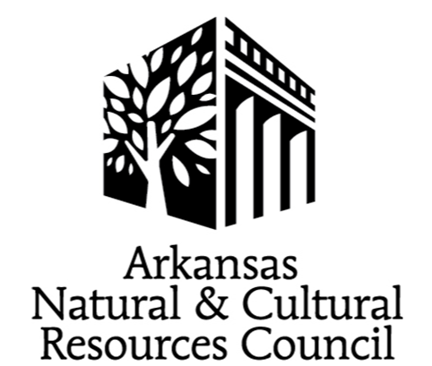

ANCRC FY 2027
Grant Application Instructions

I. Applicant Deadlines and Funding Decisions

New Online Applicants
Applicants who have not applied for an ANCRC grant online should send the contact information of the Grant Coordinator who will be completing the online application/who will be the point of contact throughout the application process. Information should be sent to Laura McClellan at Laura.McClellan@arkansas.gov by the 1st Monday in February with NEW ANCRC/organization name in the subject line to receive your organization’s logon information and additional instructions.

New ANCRC Projects
For new projects, a brief summary (one paragraph) of the project is requested. With the summary, send the contact information of the Grant Coordinator who will be completing the online application/who will be the point of contact throughout the application process. Information should be sent to Laura McClellan at Laura.McClellan@arkansas.gov by the 1st Monday in February.

The goal of the request is to assist applicants prior to the application deadline.

Historic Property Rehabilitation and Restoration Grants
Discussing preliminary construction plans with ANCRC and Arkansas Historic Preservation Program (AHPP) staff prior to application submission is recommended. Email Mollie.Waldon@arkansas.gov by the first Monday in February.

Next Phase Applicants
If Grant Coordinator/Contact information has changed, email Laura.McClellan@arkansas.gov before proceeding.

If Grant Coordinator/Contact information is the same as organization’s Previous application, access to the FY 2027 application will be open on the 3rd Monday in December at:
https://www.grantinterface.com/Home/Logon?urlkey=arkansasheritage.

ACCESS CODE: ANCRC

All Applicants

To be considered at the ANCRC Funding Meeting, applicants must complete the online application by 4 p.m. on the 1st Monday in March. Applications submitted after the deadline will not be considered.
Please review the FY 2026 Guide to Grants and the information provided at ancrc.org carefully. Email Laura McClellan, at Laura.McClellan@arkansas.gov for additional information. When emailing, please include FY 2027 ANCRC/organization name in the subject line.

Power Point presentations for the Funding Meeting are due by Wednesday May 13, 2026.
The ANCRC Funding Meeting will be on Wednesday May 20, 2026. Applicants will receive additional information in early April.
A Mandatory Grantee Meeting will be scheduled after the Funding Meeting.

II. Completing the Online Application

Questions marked with an * are required. If the question is not applicable to your project, respond NA.

Headings should be consistent throughout the application and attachments.

Round all amounts to the nearest whole dollar.

Salaries are not eligible expenses for the majority of ANCRC projects. If salaries are included in the application, provide position titles descriptions in the Additional Budget Information.

Label all attachments.

